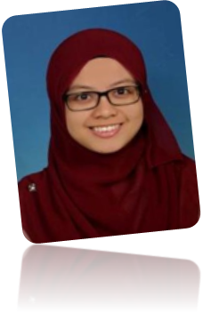


PROFILE

NIK NURUL NASHREEN BINTI NIK ABDULLAH
656, Lorong Umar Yunus, Jalan Bayam,
15200 Kota Bharu, Kelantan.

+601114962260 nashreen.nikabdullah@yahoo.com

OBJECTIVE
To obtain an engineering position in an established organization and to be exposed to different cultures and experiences.

SKILLS

English*
Bahasa Melayu*
Microsoft Office
Adobe Flash Professional CS5.5
MATLAB R2011a
Multisim 8
Proteus 7 Professional
BMC Remedy User
Customer Analysis Tool
Field Force Analysis Tool
*Language Rating for Speaking, Writing

Communication
Committed
Discipline
Work in Team

CURRICULAR VITAE

ACHIEVEMENTS

Dean’s List
Year 2013 – 2016
JPA Scholarship
Year 2014 – 2017
Malaysian University English Test (MUET)
Year 2013, Kuala Pilah, Negeri Sembilan
Band 3


EDUCATION

Universiti Teknikal Malaysia Melaka
Year 2013 – 2017, Ayer Keroh, Melaka
Bachelor’s Degree in Electronics Engineering Technology (Telecommunications)
CGPA: 3.62

Kolej Matrikulasi Neger Sembilan
Year 2012 – 2013, Kuala Pilah, Negeri Sembilan
1-year Science Module
CGPA: 2.93


ACTIVITIES

Faculty of Engineering Technology Student Association (FETSA)
Year 2015 – 2013
Academy Exco

Faculty of Engineering Technology Student Association (FETSA)
Year 2014 – 2015
Vice President

Sukan Antara Fakulti (SAF)
Year 2013 – 2016

International Innovation Festival (INNOFEST)
Year 2014
Member

WORK EXPERIENCE

Intern
Digi Telecommunications Sdn Bhd
2017, January - July
Analysing RF log file and designing solutions. I learnt about the management and process of second-level troubleshooting for enterprises complaints; from troubleshooting 2G and 3G networks, monitor alarms, implemented process to enhance coverage.


REFERENCE

Saravana Kumar a/l Nadarajah
Internship Supervisor
0123000115
SARAVANA@DIGI.COM.MY

